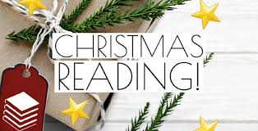

Book advent this December!

Dear Parents and Carers,
We are excited to be holding our Christmas Book Advent again this year and need your help!

What is the book advent?
The book advent contains a range of Christmas or Winter themed books which the children can unwrap each day and share with their class. This is lovely way to promote our love of reading and read new books that the children may not have heard before. Not only do your children get to enjoy reading together but they have the thrill of something to open every day in the build up to Christmas.

How can you help?
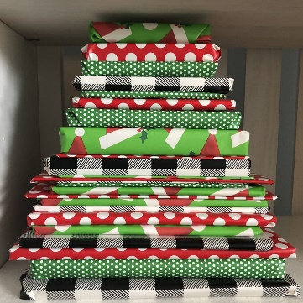
If you have any Christmas or Winter themed books at home that you would be happy for us to borrow then please ensure it is named and then wrapped up before being passed to your class teacher by Thursday 28th November.
Books will be read over the course of 3 weeks leading up to Christmas and returned once they have been shared.

Thank you for your ongoing support
Alison Knight
(Reading Leader)

