Meet the Author: Peter Bently
05/11/2025
Dear Parents,
We are delighted to say that on Tuesday 25th November your child will have the opportunity to meet children's author Peter Bently. Peter is the author of many popular children's books such as Dogdunnit and Skunk Skedaddle! which was shortlisted for last year's Portsmouth Picture Book Award. He will be in school to talk to the children about his books and being an author.

There will be an opportunity for your child to buy their own copy of one of his books and have it signed by Peter on the day if you wish. The Hayling Island Book Shop will be located in the school on the day selling a selection of Peter's books at a subsidised price of £7. Please send money into school, in an envelope, with your child on the day.

We look forward to Peter's visit and are sure the children will thoroughly enjoy the experience to listen to and meet with this well-known author.

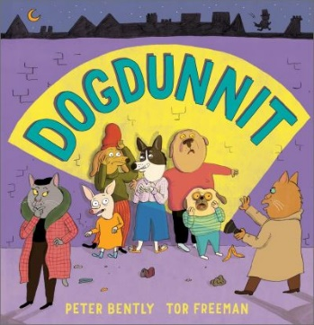
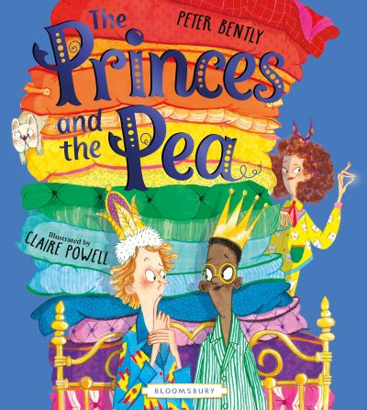
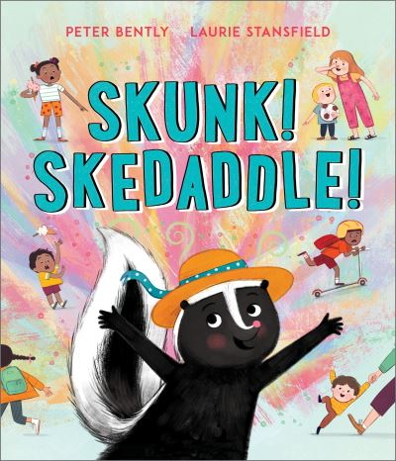
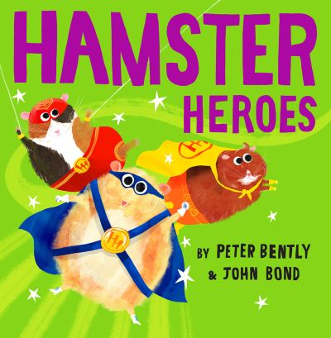
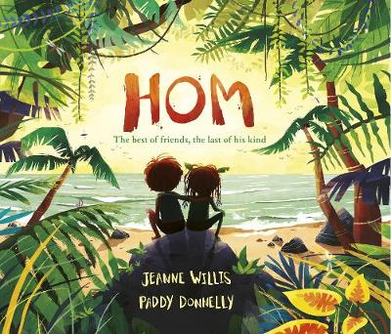

Kind regards

Ruth Vonk
Head Teacher, Meon Infant School and Moorings Way Infant School

