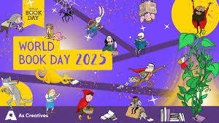

Wednesday 12th February 2025

Dear Parents/Carers,

World Book Day takes place on Thursday 6th March and we hope you’ll join us to celebrate and to promote a love of books and reading.

Dressing up or bringing books into school is a big part of World Book Day celebrations and is something that the children really enjoy. We are inviting children to dress up this World Book Day as it’s an exciting way for children share books and characters that they like and to get book recommendations from each other. We are aware that the cost of living crisis might make this difficult for some families, so we encourage you to use things you already have at home to make a creative costume

**If you have any old costumes that you no longer need then we will be accepting donations to the school office in the first week back after half term.**

Events on World Book Day;

* World Book Day assembly
* Children will be visiting teachers around the school to read a story and take part in activities linked to the book.
* 3pm – Everyone reading event. Parents, Grandparents or Carers are invited to come into school to share a book with your child. Year R will be based in ‘The Hive’, Year 1 will be based on the hall and Year 2 will be based in the Year 2 classrooms and Library. Gates will open at 2.55pm – please sign your child out when you leave.

All children will receive a free £1 book voucher– simply take your book token to your nearest bookseller and swap it for a World Book Day £1 book OR use it to get £1 off any ANY book or audiobook costing £2.99 or more.

You can find your nearest bookseller at worldbookday.com/participating-retailers

We’re very much looking forward to celebrating World Book Day, which could not happen without the support of parents and carers – thank you.

Alison Knight

Reading/Phonics leader and Assistant Head