**Pop-Up Swimming Pool Programme**

**Coming to your childs school!**

**Dear Parent/Carer,**

**I am delighted to let you know that your children will be taking part in a pop-up pool programme, Swim:ED.**

This is an amazing opportunity for your child to continue on their swimming and water safety journey. Swimming Lessons will take place at the pop-up swimming pool that is situated on our school site. The programme aims to give your child the skills and knowledge to perform safe self-rescue and acquire the lifelong skill that is swimming. Pupils will be taught by qualified swimming instructors supported by our staff and lessons will be supervised by qualified lifeguards. The programme provides a perfect opportunity for your child to learn swimming and self-rescue skills in a controlled safe environment.

**The Pop-Up Pool Programme for the Meon Schools and Moorings Way Infant School will run for 5-weeks, starting week commencing 9th June 2025. A timetable of dates will be sent out to you.**

Before the programme starts, we just need a bit of information on your child’s swimming ability and experience so we can group them accordingly. Please take 30 seconds to complete the questions via the link below, this will be a great help!

**[Parent Feedback Survey](https://survey.hsforms.com/1viqKa4CTTQStQlhPkq5dFw34o7b)**

## Expectations

As part of the National Curriculum, every child should leave primary school:

* *Be able to demonstrate safe self-rescue and evidence of this in different water-based situations.*
* *Use a range of strokes effectively, for example, front crawl and backstroke.*
* *Be able to swim confidently, competently and proficiently over a distance of at least 25m.*

## What is a Pop-up Pool?

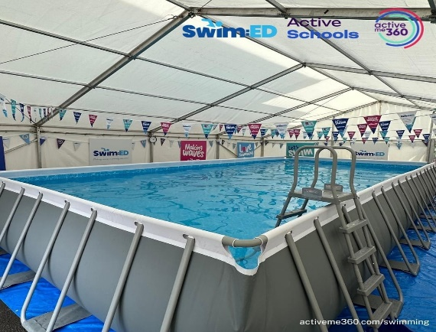A pop-up pool is a fun and exciting addition to our school's physical education program. With dimensions of approximately 10m x 5m and a depth of 1.2m, the above-ground pool structure provides a high-quality and safe swimming experience for children. The pool meets industry standards and safety requirements, ensuring that all children can enjoy a fun and secure swimming experience. Equipped with a filter and pool heater to maintain a safe water temperature, the pool is situated under a 9x15m marquee. The accompanying image provides a visual example of the pool, its setup, and structure.

## What can I do to prepare my child for school swimming lessons?

* Go swimming as a family before they start their lessons.
* Visit the Swim England parent hub at [www.swimming.org/learntoswim](http://www.swimming.org/learntoswim)
* Find your local pool at [www.swimming.org/poolfinder](http://www.swimming.org/poolfinder)
* Talk positively about going swimming and the importance of learning to swim.
* Ensure they are able to dress and undress themselves and dry themselves independently including getting into and out of their swimwear.
* Support with practicing blowing bubbles, splashing water over their face and submerging their face.

## What to wear for swimming?

* Girls to wear a one-piece swimming costume.
* Boys to wear swimming trunks or swimming shorts (above the knee).
* Children may choose to wear rash vests and or leggings for modesty if they wish.
* Goggles may be worn but remain the responsibility of the individual wearer.
* Long hair must be tied back or ideally a swimming hat worn.
* Jewellery (except for an SOS talisman) is not permitted during school swimming lessons, i.e. earrings, bracelets, necklaces, waterproof watches, rings etc.
* Please ensure your child also brings a towel with them to dry after their session!
* Slip on shoes to wear from the changing rooms to poolside.

If you have any questions please do not hesitate to speak with your class teacher.

Sincerely,

ActiveMe 360.