Year 1 Newsletter

Wow what a busy half term it has been, the children have all settled in well and have been working hard on all of the challenges of Year 1. Thank you for all of your support as we introduce the children to the new routines and expectations for the year ahead.
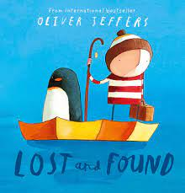
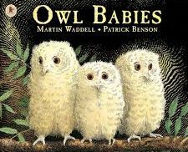

This half term our ‘Talk Through Stories’ texts are Owl Babies and Lost and Found. These sessions help us to explore the text in detail and develop comprehension skills.

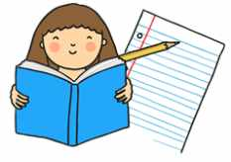
In English we will be using these books as a starting point for our writing combine elements of reading, writing and talk to plan and write a final piece. Throughout we will keep practicing perfect sentences and our handwriting – sitting letters on the line and thinking carefully about letter size.
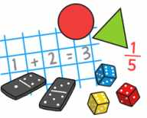
In Mathematics we will be continuing our work on number, exploring strategies for addition and subtraction. We will also be deepening our learning of place value and naming and describing 2D and 3D shapes.

Phonics | We will continue to use Oxford Owl to support reading at home. In addition you may receive an email with a link to a Phonics video – at the moment these will only be sent to specific groups if they are finding a particular sound tricky.
Phonics reading books | Thank you for supporting your child with reading this half term. Just a reminder that these books are linked to our phonics lessons and fully decodable. This means that your child should be able to attempt all words independently and begin to build up fluency.  You can challenge your child by  - Asking them to predict events  - Discuss the characters feelings  - Changing the stories ending  - Spot describing words (adjectives) in the texts
Half term challenge – In History we will be learning about homes from the past. Please can you send or bring in a picture of your kitchen at home.
office@meonwayfederation.org.uk
Curriculum subjects
Year 1 will be covering the following subjects this half term.
Science | We will be learning about animals and how to classify them – this includes mammals, birds, amphibians, reptiles, fish and insects. Then we will find out what they eat – will it be a carnivore, herbivore or omnivore?  We have a workshop with ‘The Creature Teachers’ to support our learning – this will take place on Thursday 4th December 2025 and is a fantastic hands-on animal experience for the children
DT | In Design and Technology we will be exploring joins and materials to create a windmill.
History | We will find out about our homes in our local area and then compare homes from the past with homes from today. There will be a chance to compare objects from the past and think about what they look like now.
RE | Our learning is linked to Christmas and will focus on Nativity Journeys.
PE | We will have PE with a specialist sports coach on a Wednesday afternoon.  Please ensure children wear their PE kits to school – tracksuit bottoms are encouraged.
Dates for your diary
Monday 3rd November – INSET Day
Wednesday 5th November – Guy Fawkes session (please send your child with a pair of gloves)
Tuesday 4th – Fireworks @ Moorings Way 4pm – ticket only event – see separate information
Monday 10th- Odd socks day Anti-bullying week.
Tuesday 25th November – KS1 Author Visit from Peter Bently – A great session with the chance to purchase a book which can be signed! - see Year 1 trips letter (no cost unless you would like to buy a book)
Tuesday 2nd December – Christmas Panto in school for all children (no cost – provided by FOMS)
Thursday 4th December – Creature Teacher workshops – see Year 1 trips letter
Friday 5th December –Elfridges Children’s Christmas shopping
Thursday 11th December 2pm – Christmas Concert at St James’ Church
Friday 12th December 10.00am- Christmas Concert at St James’ Church
Thursday 18th December - Non school uniform- Jumper day
Thursday 18th December- Christmas lunch and Class parties
Friday 19th December- Last day of term
Monday 5th January – INSET day
Tuesday 6th January – Spring Term begins
**Thank you all for your continued support – Mrs Chrus, Mrs Cox and Miss Barr*

