Year 2 Autumn B Newsletter
Dates:
First day back: Tuesday 4th November 2025
INSET Days:
Monday 3rd November 2025
Key Dates:
Anti-Bullying Week – Week commencing 10th November
Wonder Dome – Tuesday 11th November 2025
Children in Need – Friday 14th November 2025

Reminders
In Year 2, homework books will be given out on a Friday and will need to be returned by the following Friday. This will be on a weekly rotation of Maths and English.
Please remember to record reading at home in your child’s reading log. Children need to bring their home reader into school every day. They will receive a new home reader every Monday.
From Autumn 2, we will not be giving out weekly spellings. Instead, children will be tested on a range of spellings within English lessons. However, please do continue to practise reading and writing Year 1 and Year 2 Common Exception Words at home.

We hope you have a wonderful half term and look forward to seeing you for Autumn B.
When we come back, we will be focusing on the theme ‘Space’.
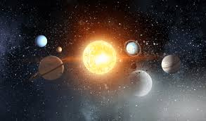

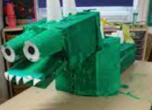
Half term project
To kick off our Space topic we would like you to choose one of the space projects below to complete over the half term break:
- Make one of the planets in the solar system
- Make a fact file/poster about the solar system.
- Design and create a model rocket ship.
- Create your own alien and write a story about it.
Please bring your projects in on Tuesday 4th November.

P.E
PE lessons in Year 2 will take place on a Tuesday afternoon. Children will need to wear their PE kit on this day. Pupils will be developing their personal skills to challenge themselves. PE is an important part of the curriculum and educates pupils in leading an active and healthy lifestyle developing skills that will equip them for life.

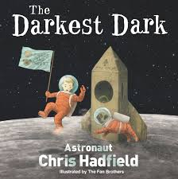
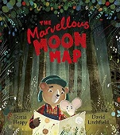
Topic
Science – This half term, children will be looking at everyday materials. They will be taking part in different investigations to understand the suitability of different materials.
Design and Technology - This half term the children will be designing a functional space buggy based on design criteria.
History - This half term we will be finding out about a significant person. To link with our space topic the children will be learning about Neil Armstrong and make comparisons with an English astronaut Tim Peake.
Computing – The children will be learning about Technology around us.
Music – Christmas Themed Music
R.E – This half term we will be learning about Waiting with a focus on ‘Advent’.

We hope you have a lovely half term!
Yours sincerely,
The Year 2 Team
Developing lifelong learners:

English
In English this half term, we are going to be focusing on two engaging Space texts called ‘The Marvellous Moon Map’ by Heapy Teresa and ‘The Darkest Dark’ by Astronaut Chris Hadfield.
The children will be using these texts to learn to how to write a newspaper report and a narrative. Alongside writing for a purpose, the children will be learning new spelling rules, using punctuation for effect and writing sentences that are grammatically correct.
Maths
In Maths this half term, the children will be continuing their learning on addition and subtraction using a variety of methods to solve problems. We will then move on to explore money by identifying the value of coins and notes as well as learning to solve money problems where the children will be required to apply known strategies to support them. Before the end of term, the children will move on to learn about multiplication and division.

